The Particle Swarm:
Explosion, Stability, and Convergence in a Multi-Dimensional
Complex Space

Maurice Clerc | James Kennedy
France Télécom | Bureau of Labor Statistics,
France | Washington, D.C.
Maurice.Clerc@WriteMe.com | Kennedy_Jim@bls.gov

Abstract

The particle swarm is an algorithm for finding optimal regions of complex search spaces through interaction of individuals in a population of particles. Though the algorithm, which is based on a metaphor of social interaction, has been shown to perform well, researchers have not adequately explained how it works. Further, traditional versions of the algorithm have had some dynamical properties that were not considered to be desirable, notably the particles’ velocities needed to be limited in order to control their trajectories. The present paper analyzes the particle’s trajectory as it moves in discrete time (the algebraic view), then progresses to the view of it in continuous time (the analytical view). A 5-dimensional depiction is developed, which completely describes the system. These analyses lead to a generalized model of the algorithm, containing a set of coefficients to control the system’s convergence tendencies. Some results of the particle swarm optimizer, implementing modifications derived from the analysis, suggest methods for altering the original algorithm in ways that eliminate problems and increase the optimization power of the particle swarm.

1. INTRODUCTION

Particle swarm adaptation has been shown to successfully optimize a wide range of continuous functions (Angeline, 1998; Kennedy and Eberhart, 1995; Kennedy, 1997; Kennedy, 1998; Shi and Eberhart, 1998). The algorithm, which is based on a metaphor of social interaction, searches a space by adjusting the trajectories of individual vectors, called “particles” as they are conceptualized as moving points in multidimensional space. The individual particles are drawn stochastically toward the positions of their own previous best performance and the best previous performance of their neighbors.

While empirical evidence has accumulated that the algorithm “works,” e.g., it is a useful tool for optimization, there has thus far been little insight into how it works. The present analysis begins with a highly simplified, deterministic version of the particle swarm in order to provide understanding about how it searches the problem space (Kennedy, 1998), then continues on to analyze the full stochastic system. A generalized model is proposed, including methods for controlling the convergence properties of the particle system. Finally, some empirical results are given, showing the performance of various implementations of the algorithm on a suite of test functions.

1.1 The particle swarm

A population of particles is initialized with random positions 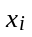 and velocities 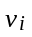, and a function, f, is evaluated, using the particle’s positional coordinates as input values. Positions and velocities are adjusted, and the function evaluated with the new coordinates at each time-step. When a particle discovers a pattern that is better than any it has found previously, it stores the coordinates in a vector 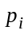. The difference between (the best point found by i so far) and the individual’s current position is stochastically added to the current velocity, causing the trajectory to oscillate around that point. Further, each particle is defined within the context of a topological neighborhood comprising itself and some other particles in the population. The stochastically weighted difference between the neighborhood’s best position 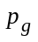 and the individual’s current position is also added to its velocity, adjusting it for the next time-step. These adjustments to the particle’s movement through the space cause it to search around the two best positions.

The algorithm in pseudocode follows:

Initialize population
Do
For i= 1 to Population Size
if f()<f() then =
=min(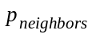)
For d = 1 to Dimension
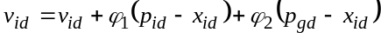
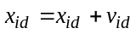
Next d
Next i
Until termination criterion is met

The variables 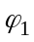 and 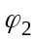 are random positive numbers, drawn from a uniform distribution and defined by an upper limit 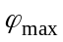 which is a parameter of the system. In this version, the term variable 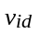 is limited to the range 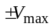, for reasons which will be explained below. The values of the elements in are determined by comparing the best performances of all the members of i’s topological neighborhood, defined by indexes of some other population members, and assigning the best performer’s index to the variable g. Thus represents the best position found by any member of the neighborhood.

The random weighting of the control parameters in the algorithm results in a kind of explosion or a “drunkard's walk” as particles’ velocities and positional coordinates careen toward infinity. The explosion has traditionally been contained through implementation of a V_{max} parameter, which limits step-size, or velocity. The current paper however demonstrates that the implementation of properly defined constriction coefficients can prevent explosion; further, these coefficients can induce particles to converge on local optima.

An important source of the swarm’s search capability is the interactions among particles as they react to one another’s findings. Analysis of interparticle effects is beyond the scope of this paper, which focuses on the trajectories of single particles.

1.2 Simplification of the system
We begin the analysis by stripping the algorithm down to a most simple form; we will add things back in later. The particle swarm formula adjusts the velocity by adding two terms to it. The two terms are of the same form, that is, 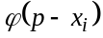, where 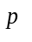is the best position found so far, by the individual particle in the first term, or by any neighbor in the second term. The formula can be shortened by redefining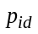 as follows:

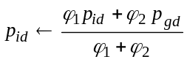

Thus we can simplify our initial investigation by looking at the behavior of a particle whose velocity is adjusted by only one term:

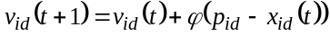,

where 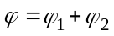. This is algebraically identical to the standard two-term form.

When the particle swarm operates on an optimization problem, the value of is constantly updated, as the system evolves toward an optimum. In order to further simplify the system and make it understandable, we set to a constant value in the following analysis. The system will also be more understandable if we make ϕ a constant as well; where normally it is defined as a random number between zero and a constant upper limit, we will remove the stochastic component initially and reintroduce it in later sections. The effect of ϕ on the system is very important, and much of the present paper is involved in analyzing its effect on the trajectory of a particle.

The system can be simplified even further by considering a 1-dimensional problem space, and again further by reducing the population to one particle. Thus we will begin by looking at a stripped-down particle by itself, e.g., a population of one, one-dimensional, deterministic particle, with a constant p.

Thus we begin by considering the reduced system:
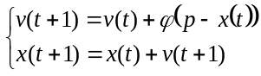 Equ. 1.1
where p and ϕ are constants. No vector notation is necessary, and there is no randomness.

Kennedy (1998) found that the simplified particle’s trajectory is dependent on the value of the control parameter ϕ, and recognized that randomness was responsible for the explosion of the system, though the mechanism which caused the explosion was not understood. Ozcan and Mohan (1998a; 1998b) further analyzed the system and concluded that the particle as seen in discrete time “surfs” on an underlying continuous foundation of sine waves.

The present paper analyzes the particle swarm as it moves in discrete time (the algebraic view), then progresses to the view of it in continuous time (the analytical view). A 5-dimensional depiction is developed, which completely describes the system. These analyses lead to a generalized model of the algorithm, containing a set of coefficients to control the system’s convergence tendencies. When randomness is re-introduced to the full model with constriction coefficients, the deleterious effects of randomness are seen to be controlled. Some results of the particle swarm optimizer, using modifications derived from the analysis, are presented; these results suggest methods for altering the original algorithm in ways that eliminate some problems and increase the optimization power of the particle swarm.

2. ALGEBRAIC POINT OF VIEW
The basic simplified dynamic system is defined by
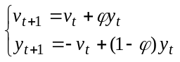 Equ. 2.1
where 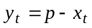.

Let 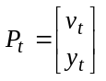 be the current point in 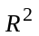, and 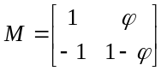 the matrix of the system. In this case we have 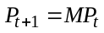 and, more generally, 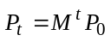. Thus the system is completely defined by M.

The eigenvalues of M are:
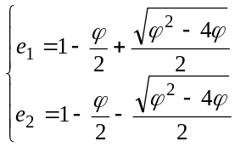 Equ. 2.2

We can immediately see that the value ϕ=4 is special; below we will see what this implies.

For ϕ ≠4 we can define a matrix A so that 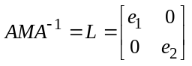 Equ. 2.3
(note that A⁻¹ doesn’t exist when ϕ =4)

For example, from the canonical form 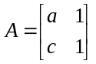 we find

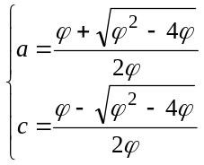 Equ. 2.4

In order to simplify the formulas, we multiply by 2ϕ, to produce a matrix A:

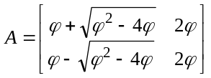 Equ. 2.5

So if we define 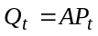 we can now write
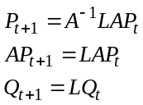 Equ. 2.6

and, finally, 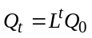
But L is a diagonal matrix, so we have simply 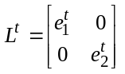 Equ. 2.7

In particular, there is cyclic behavior in the system if and only if 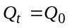 (or, more generally if 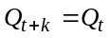). This just means that we have a system of two equations:

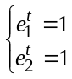 Equ. 2.8

2.1 Case ϕ <4
For 0<ϕ<4, the eigenvalues are complex, and there is always at least one (real) solution for ϕ.
More precisely we can write

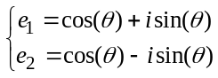 Equ. 2.9

with 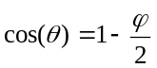 and 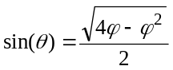 .
Then

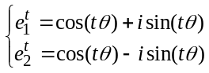 Equ. 2.10
and cycles are given by any θ such that 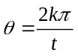

So for each t, the solutions for ϕ are given by
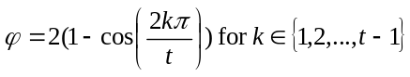 Equ. 2.11

Table 2.1 gives some nontrivial values of ϕ for which the system is cyclic.

Figures 2.1 through 2.4 show the trajectories of a particle in phase space, for various values of ϕ. When ϕ takes on one of the values from Table 2.1, the trajectory is cyclical, for any other value, the system is just quasi-cyclic, as in Figure 2.4.
Table 2.1. Some ϕ values for which the system is cyclic.
ϕ | Cycle period
3 | 3 (see Figure2.1)
2 | 4
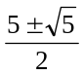 | 5 (see Figure 2.2 for the sum and Figure 2.3 for the difference)
1, 3 | 6,3
1, 2, 3, 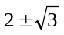 | 6, 4, 3, 12

We can be a little bit more precise. Below, 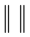 is the 2-norm (the Euclidean one for a vector),
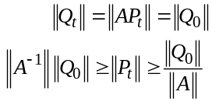 . Equ. 2.12

For example, for v₀=0 and y₀=1, we have

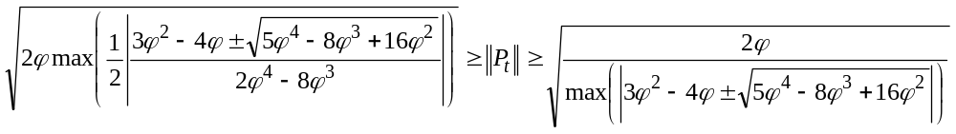 Equ. 2.13

- - - - - - - - - - - - - - - - - - - -
Figures 2.1 - 2.4
- - - - - - - - - - - - - - - - - - - -

2.2 Case ϕ >4
If ϕ>4, then e₁ and e₂ are real numbers (and 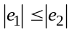), so we have either
- 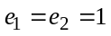 (for t even) which implies ϕ=0, not consistent with the hypothesis ϕ>4
- 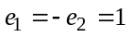 (or -1) which is impossible
- 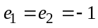that is to say ϕ=4, not consistent with the hypothesis ϕ>4

So, and this is the point, there is no cyclic behavior for ϕ>4. And, in fact, the distance from the point 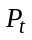 to the center (0,0) is strictly monotonic increasing with t, which means that

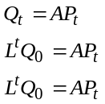 Equ. 2.14

So
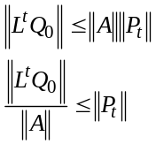 Equ. 2.15

But one can also write

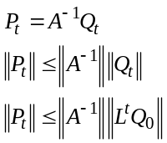 Equ. 2.16

So, finally, 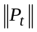 increases like 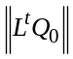.
In Section 4 this result is used to prevent the explosion of the system, which can occur when particle velocities increase without control.

2.3 Case ϕ =4
In this situation 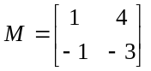

In this particular case, the eigenvalues are both equal to -1, and there is just one family of eigenvectors, generated by 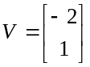. So we have 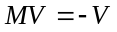.

Thus, if P₀ is an eigenvector, proportional to V (that is to say if 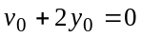), there are just two symmetrical points, for
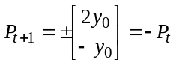 Equ. 2.17

In the case where P₀ is not an eigenvector, we can directly compute how decreases and/or increases.

Let us define 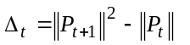. By recurrence the following form is derived:

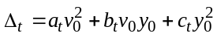 Equ. 2.18

where a_{t},b_{t},c_{t} are integers so that 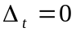for 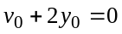. The integers can be negative, zero, or positive.

Supposing for a particular t we have 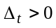, one can easily compute 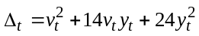. This quantity is positive if and only if v_{t} is not between (or equal to) the roots 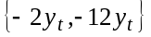
Now, if 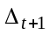 is computed then we have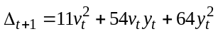, and the roots are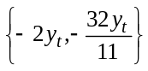. As 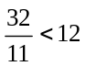, this result means that 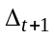 is also positive. So as soon as begins to increase, it does so infinitely. But it can decrease, at the beginning. The question to be answered next is, how long can it decrease before it begins increasing?

Now take the case of Δ₀ < 0. This means that v₀ is between -2y₀ and -12y₀. For instance, in the case where y₀>0,
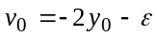, with 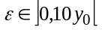 . Equ. 2.19

By recurrence, the following is derived:
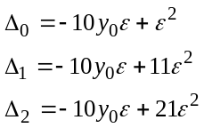
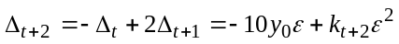, with 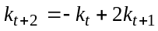 Equ. 2.20

Finally,
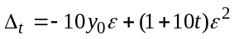 Equ. 2.21
as long as 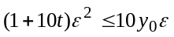, which means that 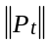 decreases as long as

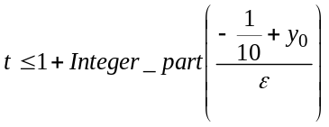 Equ. 2.22
After that, increases.

The same analysis can be performed for y₀<0. In this case ε<0, as well, so the formula is the same. In fact, to be even more precise, if
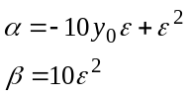
then we have

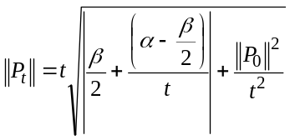 Equ. 2.23

Thus, it can be concluded that decreases/increases almost linearly when t is big enough. In particular, even if it begins to decrease, after that it tends to increase almost like 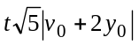.

3. ANALYTIC POINT OF VIEW

3.1 Basic explicit representation

From the basic iterative (implicit) representation, the following is derived:

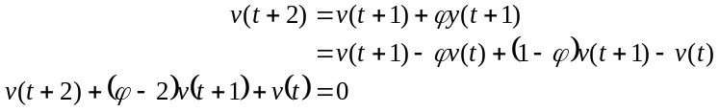 Equ. 3.1

Assuming a continuous process, this becomes a classical second order differential equation:
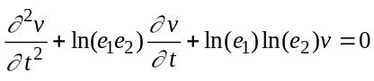 Equ. 3.2
where e₁ and e₂ are the roots of
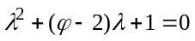 . Equ. 3.3

As a result,

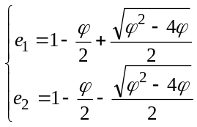 Equ. 3.4
The general solution is
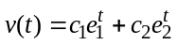 Equ. 3.5

A similar kind of expression for y(t) is now produced, where,
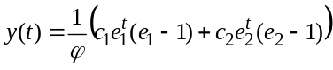 Equ. 3.6

The coefficients c₁ and c₂ depend on v(0) and y(0). If 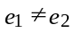, we have

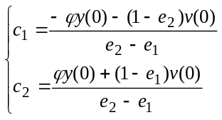 Equ. 3.7

In the case where e₁=e₂ (ϕ=4), Equ.3.5 and Equ. 3.6 give

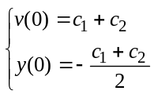 Equ. 3.8
so we must have

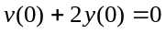 Equ. 3.9

in order to prevent a discontinuity.

Regarding the expressions e₁ and e₂, eigenvalues of the matrix M, as in Section 2 above, the same discussion about the sign of 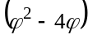 can be made, particularly about the (non) existence of cycles.

The above results provide a guideline for preventing the explosion of the system, for we can immediately see that it depends on whether we have

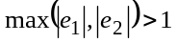. Equ. 3.10

3.2 A posteriori proof
One can directly verify that v(t) and y(t) are indeed solutions of the initial system.
On one hand, from their expressions,
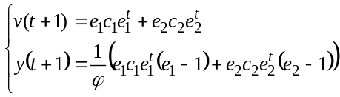 Equ. 3.11

and on the other hand,

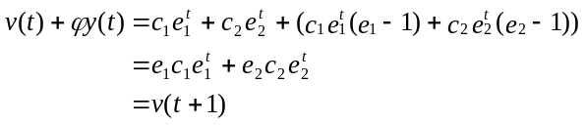Equ. 3.12
and also
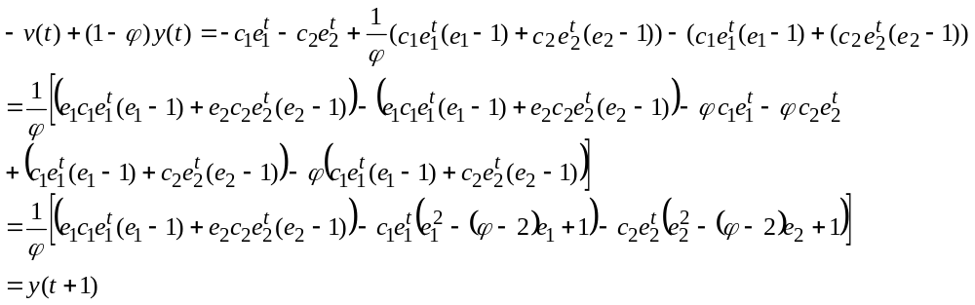Equ. 3.13

3.3 General implicit and explicit representations (IR and ER)
A more general implicit representation (IR) is produced by adding five coefficients 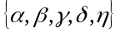, which will allow us to identify how the coefficients can be chosen in order to ensure convergence. With these coefficients the system becomes
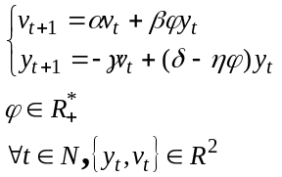 Equ. 3.14

The matrix of the system is now 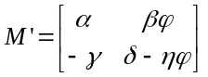. Let 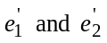be its eigenvalues.

The explicit (analytic) representation (ER) becomes
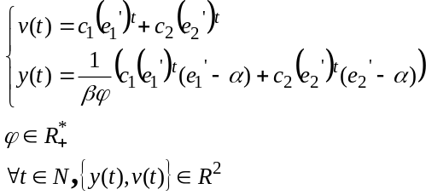 Equ. 3.15
with

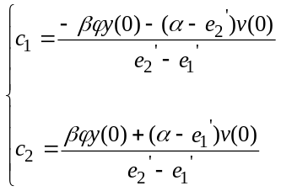 Equ. 3.16
Now the constriction coefficients (see Section 4 for details) 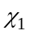and 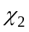 are defined by

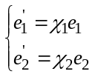. Equ. 3.17

with

Equ. 3.18

which are the eigenvalues of the basic system. By computing the eigenvalues directly and using Equ. 3.17, and are:
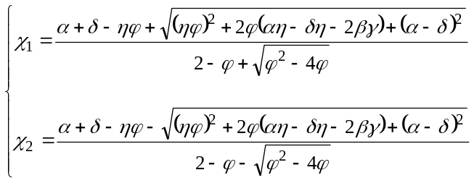 Equ. 3.19
The final complete explicit representation can then be written from 3.15 and 3.16 by replacing , respectively, by 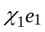and 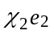, and then 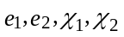by their expressions, as seen in Equ. 3.18 and 3.19.

It is immediately worth noting an important difference between IR and ER. In the IR, t is always an integer and v(t) and y(t) are real numbers. In the ER real numbers are obtained if and only if t is an integer; nothing however prevents the assignment of any real positive value to t, in which case v(t) and y(t) become true complex numbers. This fact will provide an elegant way of explaining the system’s behavior, by conceptualizing it in a 5-dimensional space, as discussed in Section 4.

Note 3.1
If 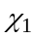 and 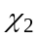 are to be real numbers for a given ϕ value, there must be some relations among the five real coefficients 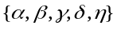. If the imaginary parts of and are set equal to zero, the following is obtained:
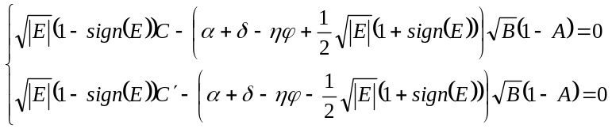 Equ. 3.20
with
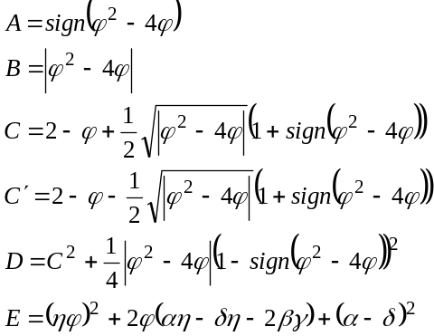 Equ. 3.21

The two equalities of Equ. 3.20 can be combined and simplified as follows:
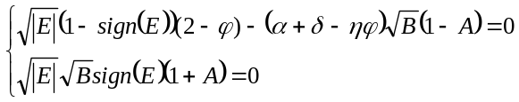 Equ. 3.22

The solutions are usually not completely independent of ϕ. In order to satisfy these equations, a set of possible conditions is
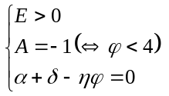 Equ. 3.23

But these conditions are not necessary. For example, an interesting particular situation (studied below) exists where 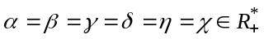. In this case 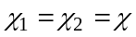for any ϕ value, and Equ. 3.20 is always satisfied.

3.4 From ER to IR
The explicit representation will be useful to find convergence conditions. Nevertheless, in practice, the iterative form obtained from Equ. 3.19 is very useful:

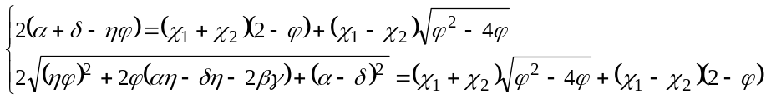 Equ. 3.24

Although there are an infinity of solutions in terms of the five parameters 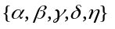, it is interesting to identify some particular classes of solutions. This will be done in the next section.

3.5 Particular Classes of Solutions

3.5.1 Class 1 model
The first model implementing the five-parameter generalization is defined by the following relations:
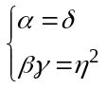 Equ. 3.25

In this particular case, α and η are

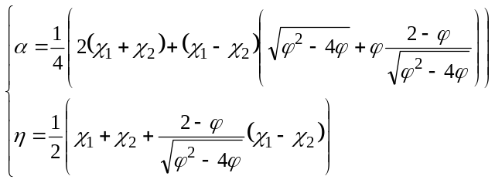 Equ. 3.26

An easy way to ensure real coefficients is to have 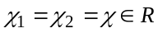. Under this additional condition, a class of solution is simply given by
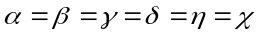 Equ. 3.27

3.5.2 Class 1' model
A related class of model is defined by the following relation:
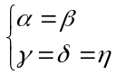 Equ. 3.28

The following expressions for α and γ are derived from Equ. 3.24:
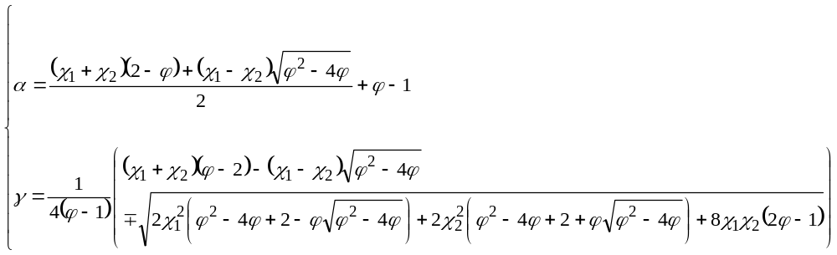 Equ. 3.29

If the condition 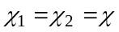 is added, then
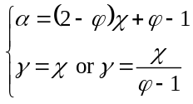 Equ. 3.30
Without this condition, one can choose a value for γ, for example 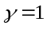, and a corresponding α value 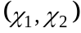 which give a convergent system.

3.5.3 Class 1" model
A second model related to the Class 1 formula is defined by
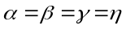 Equ. 3.31
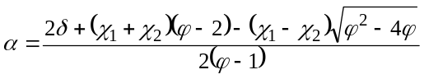 Equ. 3.32
For historical reasons and for its simplicity, the case 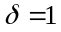 has been well studied. See Section 4.3 for further discussion.

3.5.4 Class 2 model
A second class of models is defined by the relations
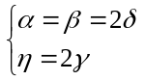 Equ. 3.33
Under these constraints it is clear that
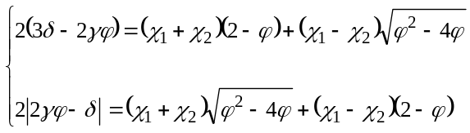 Equ. 3.34

which gives us γ and δ, respectively.

Again, an easy way to obtain real coefficients for every ϕ value is to have . In this case,
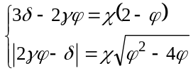 Equ. 3.35

In the case where 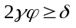 the following is obtained:
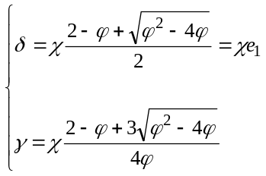 Equ. 3.36

From the standpoint of convergence it is interesting to note that we have
- for the Class 1 models, with the condition
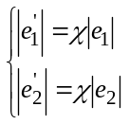 Equ. 3.37

- for the Class 1' models, with the conditions and 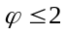
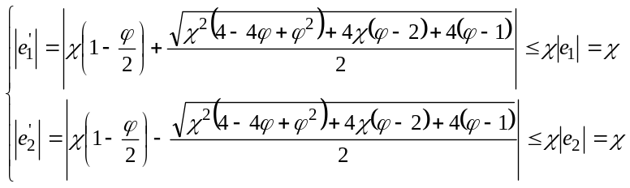 Equ. 3.38

- and for the the Class 2 models
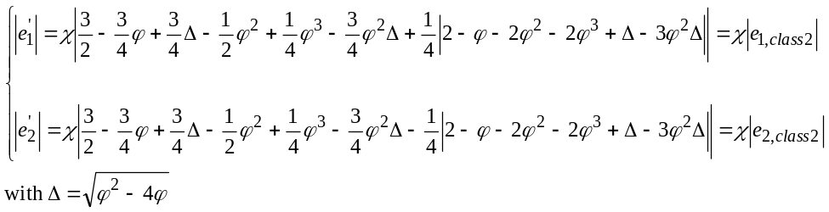 Equ. 3.39

This means that we will just have to choose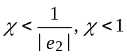 and 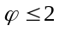, 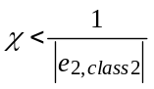 respectively, to have a convergent system. This will be discussed further in Section 4.

3.6 Removing the discontinuity
Depending on the parameters the system may have a discontinuity in ϕ due to the presence of the term 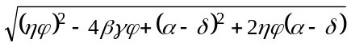 in the eigenvalues.

Thus, in order to have a completely continuous system, the values for must be chosen such that
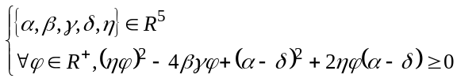 Equ. 3.40

By computing the discriminant, the last condition is found to be equivalent to

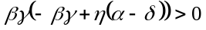 Equ. 3.41

In order to be “physically plausible,” the parameters must be positive. So the condition becomes
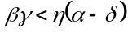 Equ. 3.42
The set of conditions taken together specify a volume in 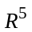for the admissible values of the parameters.

3.7 Removing the imaginary part
When the condition specified in Equ. 3.42 is met, the trajectory is usually still partly in a complex space whenever one of the eigenvalues is negative, due to the fact that 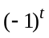is a complex number when t is not an integer. In order to prevent this, we must find some stronger conditions in order to maintain positive eigenvalues.

Since
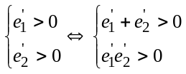 Equ. 3.43

the following conditions can be used to ensure positive eigenvalues:
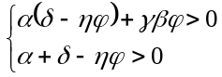 Equ. 3.44

Note 3.2
From an algebraic point of view, the conditions described in Equ. 3.43 can be written as
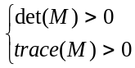 Equ. 3.45

But now these conditions depend on ϕ. Nevertheless, if the maximum ϕ value is known, they can be rewritten as:
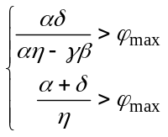 Equ. 3.46

Under these conditions, all system variables are real numbers. in conjunction with the conditions in Equ’s. 3.42 and 3.44, the parameters can be selected so that the system is completely continuous and real.

3.8 Example
As an example, suppose that 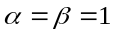 and 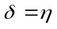. Now the conditions become
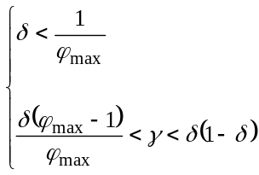 Equ. 3.47

For example, when
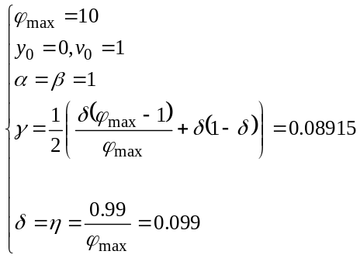 , Equ. 3.48

the system converges quite quickly after about 25 time steps, and at each time step the values of y and v are almost the same over a large range of ϕ values. Figure 3.1 shows an example of convergence (v≥0 and y≥0 ) for a continuous, real-valued system with ϕ = 4.

3.9 Reality and convergence
The quick convergence seen in the above example suggests an interesting question. Does reality – using real-valued variables – imply convergence? In other words, does the following hold for real-valued system parameters?

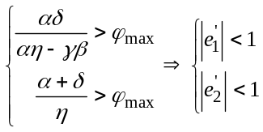 Equ. 3.49

The answer is no. It can be demonstrated that convergence is not always guaranteed for real-valued variables. For example, given the following parameterization:

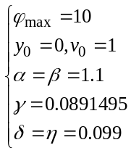 Equ. 3.50

the relations are
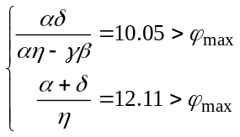 Equ. 3.51
which will produce system divergence when 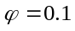(for instance), since 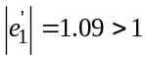. This is seen in Figure 3.2.

- - - - - - - - - - - - - - - -
Figures 3.1 and 3.2
- - - - - - - - - - - - - - -

Note that the present paper uses the Bourbaki convention of representing open intervals with reversed brackets. Thus ]a,b[ is equivalent to parenthetical notation (a,b).

